Notification to Apply for SUN Bucks

Dear Parent or Guardian:

If your household income is less than 185% of the Federal level, the school aged children in your household may be eligible for a new program called SUN Bucks. Households that have been notified of eligibility by Direct Certification do not need to apply.

Participating families will receive $120 for each eligible child on a card that you can use to buy food during the summer at grocery stores, farmers markets, and other authorized retailers. If you think your children are eligible, you can get SUN Bucks by filling out a simple application. To apply for SUN Bucks, apply via your child’s school by Wednesday, May 1 or after Wednesday, May 1 visit https://indianasunbucks.com. Applications will be accepted until Friday, August 16, 2024 in order to get benefits for this summer. If you need assistance filling out an application, or if you have questions, submit a ticket to the online help form: https://idoe.atlassian.net/servicedesk/customer/portal/11.

You will need to provide your child’s name, school, date of birth, along with the names of other people in your household, your household income, and address where you would like the benefit card to be sent. You will not need to provide any documentation to apply. Receiving Summer EBT will not affect children or families’ immigration status.

In addition to SUN Bucks the children under 18 years of age in your household can also receive free meals during the summer at a summer meal site. You can call 1-866-3-HUNGRY or 1-877-8-HAMBRE (or text 914-342-7744 with the keyword “summer meals”) to find the location closest to you.

If you have questions, you can contact Becky Self at becky.self@springville.academy or 812-508-6078.

Sincerely,
Becky Self
Kitchen Manager at Springville Academy

If approved and you receive more than $120 per eligible child in your household, do not use the benefits, and submit a ticket ot he online help form https://idoe.atlassian.net/servicedesk/customer/portal/11 as soon as possible to confirm or correct the error.

FEDERAL ELIGIBILITY INCOME CHART For School Year 2023-24
Household size | Yearly | Monthly | Weekly
1 | 26,973 | 2,248 | 519
2 | 36,482 | 3,041 | 702
3 | 45,991 | 3,833 | 885
4 | 55,500 | 4,625 | 1,068
5 | 65,009 | 5,418 | 1,251
6 | 74,518 | 6,210 | 1,434
7 | 84,027 | 7,003 | 1,616
8 | 93,536 | 7,795 | 1,799
Each additional person: | +9,509 | +793 | +183

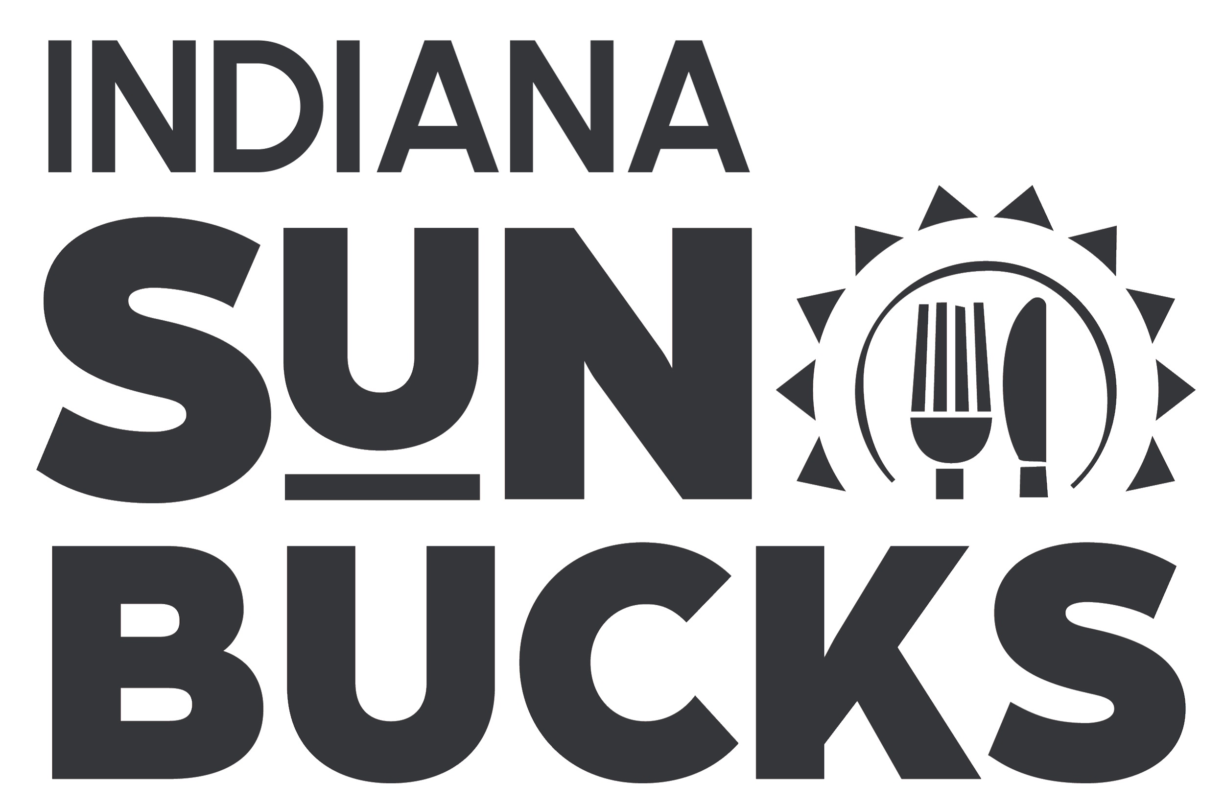

Non-Discrimination Statement: This explains what to do if you believe you have been treated unfairly.
In accordance with federal civil rights law and U.S. Department of Agriculture (USDA) civil rights regulations and policies, this institution is prohibited from discriminating on the basis of race, color, national origin, sex (including gender identity and sexual orientation), disability, age, or reprisal or retaliation for prior civil rights activity.
Program information may be made available in languages other than English. Persons with disabilities who require alternative means of communication to obtain program information (e.g., Braille, large print, audiotape, American Sign Language), should contact the responsible state or local agency that administers the program or USDA’s TARGET Center at (202) 720-2600 (voice and TTY) or contact USDA through the Federal Relay Service at (800) 877-8339.
To file a program discrimination complaint, a Complainant should complete a Form AD-3027, USDA Program Discrimination Complaint Form which can be obtained online at: https://www.usda.gov/sites/default/files/documents/ad-3027.pdf, from any USDA office, by calling (866) 632-9992, or by writing a letter addressed to USDA. The letter must contain the complainant’s name, address, telephone number, and a written description of the alleged discriminatory action in sufficient detail to inform the Assistant Secretary for Civil Rights (ASCR) about the nature and date of an alleged civil rights violation. The completed AD-3027 form or letter must be submitted to USDA by:
mail: U.S. Department of Agriculture, Office of the Assistant Secretary for Civil Rights, 1400 Independence Avenue, SW, Washington, D.C.20250-9410;or fax: (833) 256-1665 or (202) 690-7442; or email:program.intake@usda.gov
This institution is an equal opportunity provider.

